NYCC Archives – Spring 2012

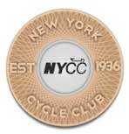
April-May “President’s Message”
By Ellen Jaffe 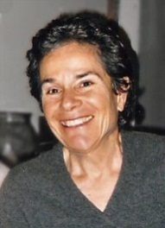
Fellow NYCC Members,
“Save Cycling” was the title of this year’s Bike Summit in Washington DC on March 20-22 and I was there representing NYCC with 800 others from every niche of the American cycling world.
Sponsored by the League of American Bicyclists, this important assembly was laser-focused on defending critical funding for bicycling programs in an age of congressional devolution.
The opening session featured “bikepartisan” Earl Blumenauer (Democrat, Oregon) who spoke about bicycling as a political movement, and how he sees it inevitably weaving into the fabric of everyday life in this country.
Ray LaHood, Transportation Secretary, stirred the crowd with his clarion call to Congress: “Pass the Senate Transportation Bill!” The Senate bill, the one in which funding for cycling and Safe Streets to School initiatives has been restored, is a revision of the disastrous House bill.
Said Peter DeFazio (another Democrat, Oregon) about members of Congress keen to pull funding: “We have to educate these people!”
From Donna Edwards (Democrat Maryland): “It’s about making our communities livable, walkable. When you advocate for cycling, you are advocating to save our communities.”
Last in the opening session was Jonathan Jarvis, Director of the National Parks Service who spoke of “Healthy Parks, Healthy People, a prescriptive NPS program aimed at getting people outdoors and active, as in: ‘take a ride and call me in the morning’!”
In the breakout sessions one thing stood out loud and clear, that bicycling means big business and that communicating the value of this $6 billion industry to officials at all levels of government, to promote public funding and pro-bicycling policy, is our urgent responsibility.
If I learned nothing else at the Summit, that takeaway, about cycling’s economic clout, how it has successfully boosted local economic vitality, was worth the price of admission.
At lunch I sat with a group of Arkansan cycling advocates whose astonishing list of accomplishments include seeing through a connected web of Little Rock parks and trails including, the Big Dam Bridge, the country’s longest pedestrian/bicycle bridge built specifically for that purpose.
Clearly something is shifting here. The Marriott could barely contain the crowd. And though the Summit is sponsored by LAB, all three big U.S. advocacy organizations. LAB, Bikes Belong and Alliance for Biking and Walking are discussing consolidation into one flagship entity that will have enormous clout.
It’s a sea change we’re in, reflecting a nationwide movement towards livable, sustainable towns and cities, with bicycling a serious transport option and growing recreational endeavor.
This gives us as devoted cyclists, and as New York City’s largest recreational club, an important role to play in our own backyard, as advocates, as communicators of the value that cycling brings to our community and to those we ride through.
Our goals are not dissimilar to those of the Arkansan advocates who by building the Three Dams Bridge built a bridge to economic growth and quality of life, to health and fitness, to friendship and community.
Our goals are not dissimilar to those of the Arkansan advocates who by building the Three Dams Bridge built a bridge to economic growth and quality of life, to health and fitness, to friendship and community.
There will surely be opportunity in the next months for NYCC members to demonstrate support for pro-bicycling policy. With an ever more clear picture of the kind of positive change this can generate, who would not want to get onboard?
Hope to see you on the road.
Ellen
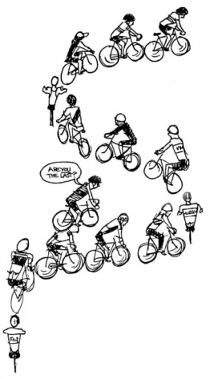

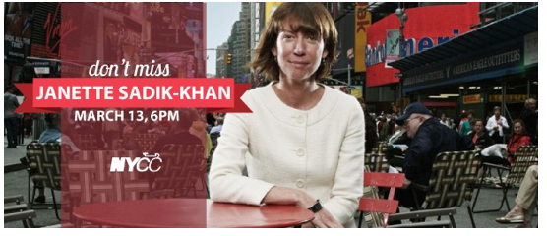
March 13 Club Meeting: Janette Sadik-Khan, Commissioner DOT and Josh Benson, DOT Bicycle Programs Coordinator
Leader, visionary, mover and shaker, lightning rod for sustainable change − our Commissioner of Transportation joins us at this historic evening for NYCC to share her thoughts about the future of our city.

WOW! THE SILENT AUCTION FOR KIDS RIDE CLUB ROCKS!

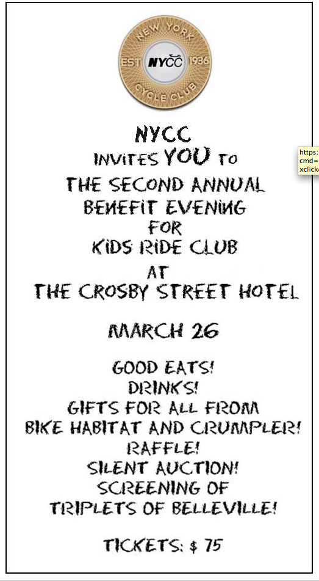
These are just some of the items available in the auction − all contributed or sourced by NYCC members!

The auction ends on March 26 at the Kids Ride Club Benefit.
Gran Fondo NJ Registration
Dinners + Broadway shows!
'Nights On the Town' in Piermont!
Private Tennis Lesson!
Yoga for cyclist session!
Photoshop class!
Sports massages!
Kreitler rollers!
Rosenthal Liberty Jerseys!
Wheelbuilding classes!
Bike Fitting & Tuneups!
Piermont Bicycle Connection - $ 100 Gift Certificate!
Gift Certificate to 9W Palisades Market and Filling Station − $ 50 Gift Certificate!
Sewing Services!
Resume Services!
iBike Computer!

and more!

NYCC Berkshires − Memorial Day Weekend, May 25-28, 2012

Spring is around the corner and the NYCC 2012 Berkshires Weekend is 3 months away.

There will be 3-4 days of cycling through beautiful country roads, farmland and the Berkshire Hills. There will be rides for cyclists at every level.

And we're returning to the Egremont Country Club on Sunday, May 27th for our windup dinner and dancing!
Join us for fun rides and socializing. If you have any doubts, ask anyone who was with us in 2011. We'll have sign-up details soon.

"Bold New Direction for the New York Cycle Club"
Velojoy's new series on women who are leading the way to encourage and support cycling in New York City focuses on our own Ellen Jaffe.
Read Velojoy's article............ Our new series on women who are leading the way to encourage and support cycling in New York City begins with Ellen Jaffe, president of the New York Cycle Club.
‘Jaffe says. “I want to underline that we’re one club with common goals: to be outstanding members of the cycling community, to promote the thing we love, and to have a great time doing it.”
Although the odometer on her 12-year-old titanium Litespeed road bike has clocked more than 50,000 miles, Jaffe concedes that she has little time for the road these days. Registration for the club’s noted SIG (special interest group) training series of progressive rides, which draws 500 participants and leaders annually, kicks off this week. Among upcoming events is a March 26 film screening at the Crosby Street Hotel to benefit the Kids Ride Club, which encourages cycling and healthy habits among youth. The scheduled speaker for club’s March meeting? NYC Transportation Commissioner Janette Sadik-Khan.
“Now, more than ever,” says Jaffe, “with all the changes going on in cycling, there’s a broader role for the club.”’

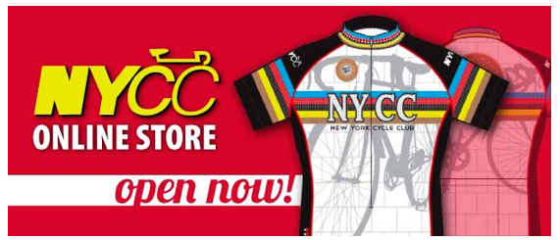

2012 NYCC Gear is Now Available in our Online Store!

Pre-order your 2012 NYCC jersey, shorts, bib shorts and arm warmers.

Primal Wear sizing chart

The store closes on March 20 with approximate delivery date June 1.

Please note there are no exchanges or returns.

2012 NYCC kit designed by Rolando Felix

Deserving Ride Leaders: If you led three or more rides in 2011 you qualify for Club gear!
The formula:
Lead 3-5 rides = NYCC water bottle
Lead 6-11 rides = NYCC socks
Lead 12+ rides = NYCC Ride Leader Vest (you can't buy these, you can only earn them)
Check the chart below to see what you get!

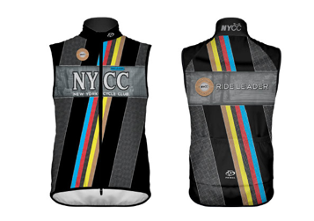

This is the spectacular mid-weight custom Ride Leader Vest, designed by Rolando Felix, for those who qualify with 12 or more leads.

Our incentives coordinator will notify all leaders who qualify for the custom Ride Leader Vest to determine correct size.

We plan to have a vest 'fit kit' at the February 14 meeting. Women's and men's sizing available.
2012 NYCC cap designed by Rolando Felix
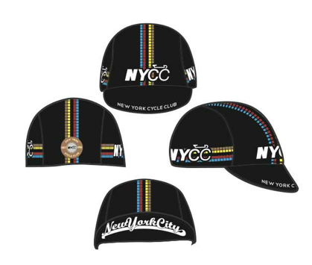

NYCC Cycling Cap Available in Our Online Store!

Two choices available:

Version 1: 'New York City' on reverse of brim

Version 2: blank under brim

The store closes on March 20 with approximate delivery date June 1.

Please note there are no exchanges or returns.

2012 NYCC cap designed by Rolando Felix

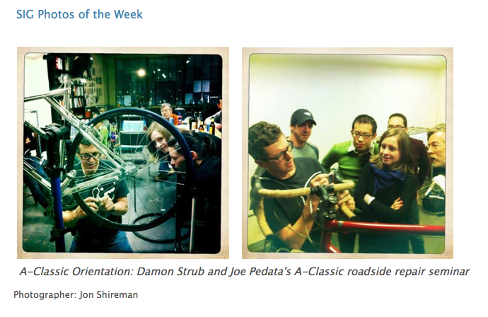

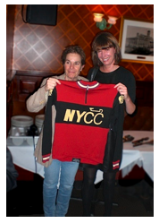
DOT's JSK Welcomed at NYCC March Club Meeting
By Grace Lichtenstein, NYCC Public Relations Director

Every cyclist's favorite city official, Transportation Commissioner Janette Sadik-Khan, made her long-awaited visits to a Club meeting last Tuesday and urged everyone to "demonstrate your support" for more protected bike lanes, the coming bike-share program and other benefits that have been implemented by the Bloomberg administration over the past five years.

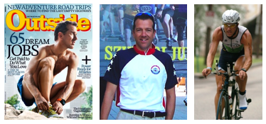
April 10 Club Meeting - MAXIMIZE Your Training with Mikael Hanson

Do you want to ride faster and climb better?
Are you getting the most out of your time training on the bike?
Come to the April Club meeting where Mikael Hanson, a pro cycling/multi-sport endurance coach, will teach you how to REALLY maximize your training and improve your performance.
Hear about the latest technological innovations in cycling, used to measure performance, and learn how to effectively utilize them to help you ride faster and more efficiently.
Learn how aging athletes are riding faster, by training smarter, on (and off) the bike.
Club Meeting Sponsor: Manhattan Grand Optical, in collaboration with Rudy Project and Oakley, is proud to sponsor the April meeting!

IN MEMORIAM: DANA GORDON, 1961-2012
With great sadness, we received news on Thursday that Dana Gordon, devoted NYCC member, passed away. She died of cancer.
Dana was a ride and SIG leader and for several years contributed her professional editorial chops as a member of the NYCC Board of Directors, sharing design and content duties with Carol Krol to consistently produce a stunning Club bulletin. Dana's bright personality and positive energy were always a joy to be around.
Our condolences go out to her husband Steve and their family.
We at NYCC will surely miss Dana.
Shiva calls on the family can be made this week in the evenings starting at 5:00pm at 205 West End Avenue, Apt 21-T (entrance on 70th).

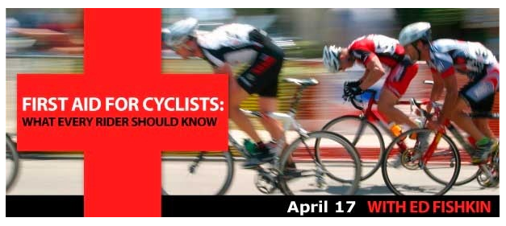
Join Dr. Ed Fishkin, Medical Director of Woodhull Hospital and lifetime NYCC member for this indispensable evening.
Learn the essentials of response and prevention of medical emergencies on the road.
Date: April 17, 2012
Time: 6:00pm - 8:30pm
Place: Woodhull Medical Center, Conference Room 2 (10 minutes from Manhattan by subway)
Fee: $20 (100% of proceeds go to support the Kids Ride Club)
Dinner will be served

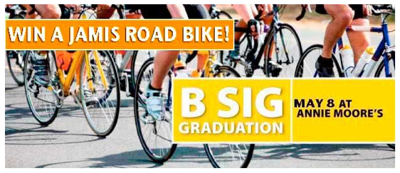
May 8th Club Meeting - B-SIGGIES Graduate!
To all 2012 B-SIGGIES: Our May 8th meeting is NYCC's official acknowledgement of your efforts and success − the B-SIG graduation! Come and enjoy your well-deserved recognition.
To everyone else: Join us in cheering and commending this year's graduating B-SIGGIES!
To honor our SIGGIES, we are thrilled to announce that Gran Fondo New Jersey and Jamis Bicyclesare generously sponsoring our May 8th Club meeting with a spectacular meeting raffle!
If you're lucky, you could win a brand new Jamis Xenith Endura Comp road bike!!!
Date: Tuesday, May 8
Time: 6:00pm - 9:00pm
Place: Annie Moore's Bar & Restaurant (downstairs)

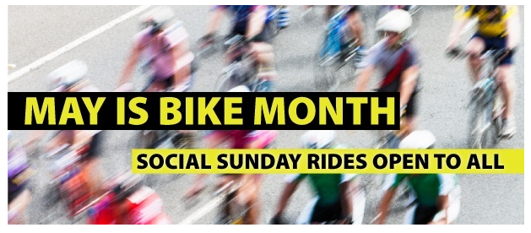
Thinking of joining NYCC? Don't know anyone who rides? New to the Club? Want to relax and catch up with friends after yesterday's demanding ride?
Here's your answer: a New York Cycle Club Social Sunday ride during Bike Month!
Social Sundays are shorter, leisurely rides that almost always involve food along the way and you don't need to be an NYCC member to participate!
You do need a bike in good working order with fully inflated tires, a helmet, water and $ for lunch.
May 6 − RAAM "Ride Almost Around Manhattan"
Start time: 9:15am
Start Location: Garden People's Garden (Riverside Park mid-level promenade, between 90-91st Street)
Leaders: Ken and Marilyn Weissman

May 13 − The Rockaways
Start time: 9:00am
Start Location: TBD
Leaders: Linda Wintner and Ellen Jaffe

May 20 - Fairway to Fairway, 125th Street, Manhattan to Red Hook, Brooklyn
Start time: 9:00am
Start Location: West Harlem Piers Park, Hudson River Greenway (opposite Fairway at 131/132 Street)
Leaders: Ken and Marilyn Weissman

Photo of the Week
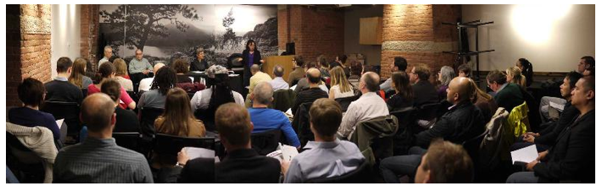
April 10th's amazingly informative Ride Leader Training seminar for siggies played to a full house.
All thanks go to:
VP of Rides Adrienne Browning, B-SIG Coordinator Wayne Wright, SIG leaders Linda Wintner and Paul Hoffherr and to REI for hosting our seminar in their Community Room

NYCC Message Board Spotlight
The NYCC Message Board is a highly valued public platform for cycling-related discourse. In this section of our eWeekly, we will spotlight postings that matter to us all.
We begin our series with a posting by NYCC Board member Carol Waaser, written in response to the furor over a cyclist's mistaken arrest by the NYPD last week,.
"Ah, the eternal question...can one be more effective at bringing about change by pummeling the establishment from the outside thru civil protest or by working within proscribed protocols and using the democratic (small "d") political process? I suspect the two methods reinforce each other, and some combination of loud, public civil protest paired with intelligent behind-the-scenes political work is what eventually carries the day. Cyclists are by no means the only group singled out by the NYPD for special treatment, and right now we're seeing both the public protest forces and the political forces chipping away at this problem.
NYCC has been doing a lot of behind-the-scenes work (in addition to attending public demonstrations) and we encourage members to join this fight in whatever manner is comfortable for them. If you don't want to be on the front lines of civil protest, then take a minute to write an email to your City Council Member (and copy all the likely Mayoral candidates: Quinn, de Blasio, Stringer, Thompson, Liu...) and tell them you're a cyclist, you want the city to be more bicycle-friendly, and that includes getting more respect from the NYPD in terms of both not harassing cyclists with unwarranted tickets and aggressively investigating cyclist injuries and deaths at the hands of reckless drivers. You can do this anytime; no need to wait for a specific call to action."
Message Board Post: "What, dear friends, will it take to make you pissed off?"

Members Corner
This is where NYCC shares cycling experiences as submitted by our members.
Did you just complete an awesome cycling trip? Is there some cycling knowledge you wish to share?
Email your write-up to bulletineditor@nycc.org.
This month's submission is by Jay Jacobson, an NYCC member since 1992, who writes about his trip to Sri Lanka.
Read "Four Hundred Gorgeous but Harrowing Miles in Sri Lanka"

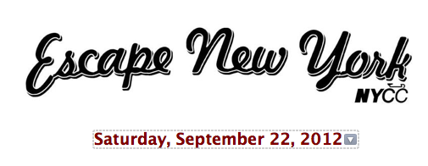
Spread the word that registration is now open for Escape New York − the highlight of the fall riding calendar in the New York City area!
Mark your calendar to volunteer for ENY and help others enjoy the hospitality of the New York Cycle Club as we go all out to deliver a food- and fun-filled, fabulous day of riding to all our friends in the cycling community. Details on how to volunteer to come soon!
2012 Escape New York Jersey!
This limited edition jersey is available now for pre-order.
The order window closes on June 1 for September delivery.
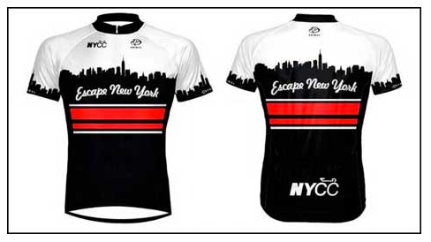

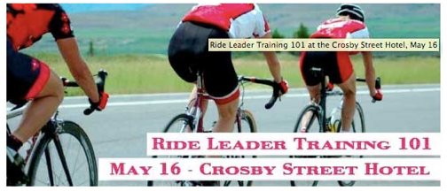
Ride Leader Training, May 16 - Crosby Street Hotel
Learn the basics of leading a ride: choosing a route, cue sheet preparation, ride submission, pre-ride talk, handling the group, and emergency response.
We will talk about some ideas for fun rides to lead. We will also tell you why you should want to lead a ride − not just to pay back NYCC for the free SIG training you're getting and not just for the free NYCC clothing you get for doing so!
Presenters will be Linda Wintner, Paul Hofherr, and Adrienne Browning.
Join us at 6:15pm for drinks, courtesy of our friends at the Crosby!
Class begins at 7:00pm

Photos of the Week - SIG Graduation Rides!
The A-Classic in Cold Spring, photos by Bob Cowin

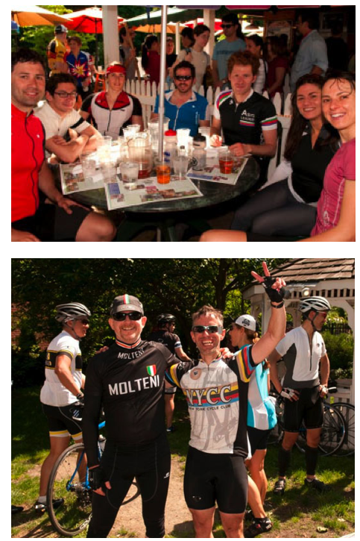

The C SIG in Piermont, photos by John Kalish

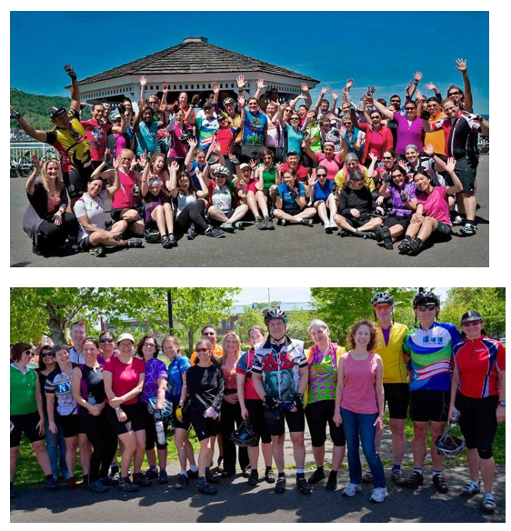

Thanks to Gran Fondo New Jersey and Jamis Bicycles!

For their generous support of our May 8th Club meeting!
And congratulations to Raoul Edwards, lucky winner of the raffle and the Jamis Xenith Endura Comp road bike!

