NYCC Archives – Summer 2012

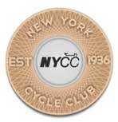
June-July “President’s Message”
By Ellen Jaffe 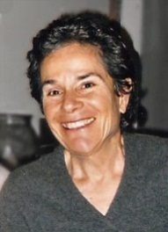
Fellow NYCC Members,
If there are crown jewels of New York Cycle Club, at the top of the list must be our spring training series, now such a well-known and respected start to the NYC cycling season that anxious inquiries come in year-round as to when signup opens.
The 2012 season of both the SIG and STS only added more luster to NYCC, from all accounts both an outstanding success, training, educating and generally imparting untold joy of the road to 500-plus lucky participants.
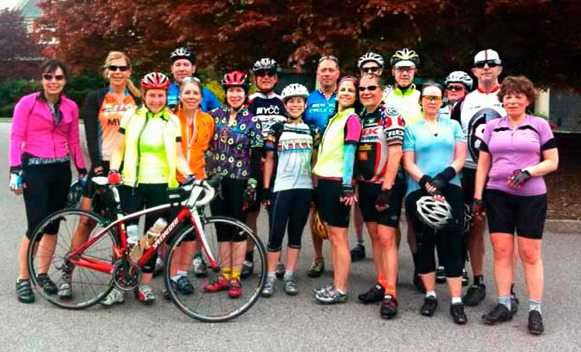

Our gratitude and thanks goes out to those key members who made these phenomenal programs hum in 2012:
To Lisa Helburn, who picked up the C-SIG reins from godfathers Gary McGraime and Paul Hofherr and ran with it.
To Mitch Rubenstein and Sarah Tombaugh for running a superb A-Classic for the second year in a row; this time graduating an unusually high percentage of women.
To George Arcarola, past president and present A-19 captain for this year’s superior program.
To Wayne Wright who set a standard of excellence when he took on the B-SIG several years back and has only ever raised the bar higher still.
And to our 125-plus SIG group leaders who gave so much of themselves, their enthusiasm, energy and knowledge.
Our STS leadership equally did the club proud this spring, running three levels for our more seasoned members.
To Gerald Seppey, A-STS captain, Victor Baruh and Dave Sabbarese, B-STS captains, Laurie Godfrey, Kate Mostkoff and Tamara Lipshie, C-STS captains, congratulations on a great season and thanks your outstanding contribution to the club.
To our chiefs and leaders…the excellence of the SIG and STS enriches NYCC in a way money can’t buy.
Congrats to you all for your success from the NYCC Board of Directors and myself.
* * *
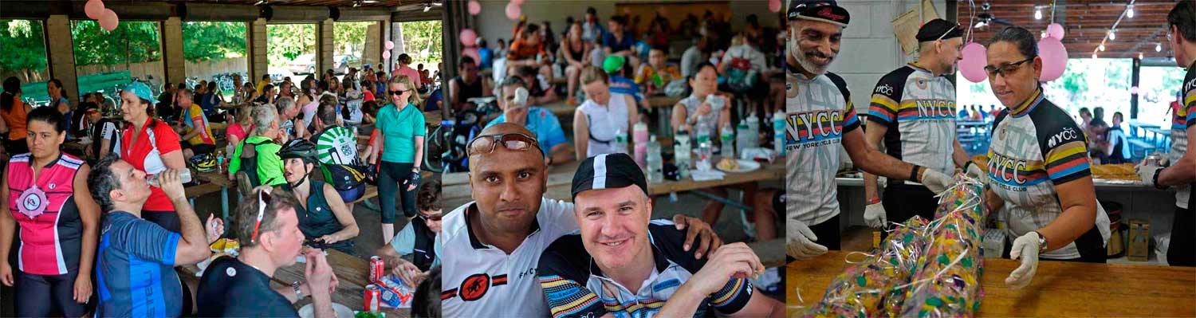
On a somewhat different note, after 18 months as president and what has felt like a non-stop train expanding what we do with events, programs, promotion, communications, advocacy, merchandising and outreach, I felt I badly needed a moment of clarity, some way to see the forest from the trees.
I got it big-time at Newcomers on June 10.
Looking out at that energized crowd of 250, by far a record, was a revelation. In that wonderful mayhem, under the wooden trusses of Goswick was the energy that will drive our club’s future; young, diverse, exuberant, seemingly eager to pitch in. It was a magic moment for me, during a terrific day for the club and the real payoff for what I do; underlining the expansive, welcoming NYCC that we are.
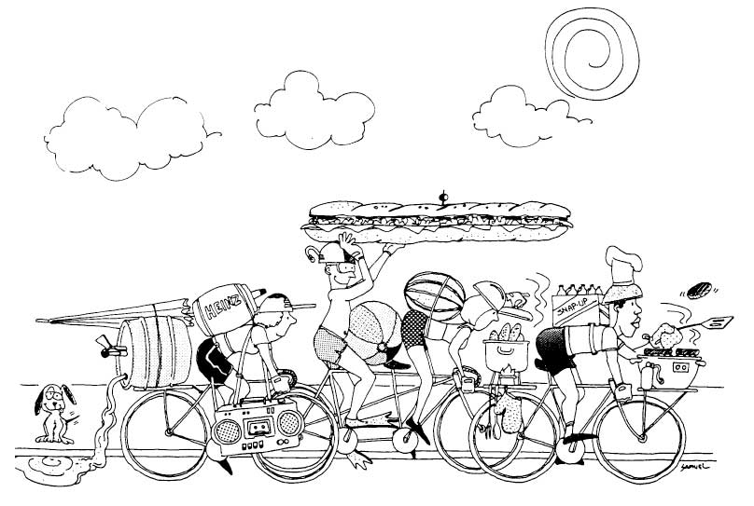
Graphic: Mike Samuel
Speaking of which, with your help as leaders, we will continue our Social Sunday series through the full cycling season.
The spotlight is on us. (link: http://citibikenyc.com/resources)
NYCC can be a deep resource for those newly interested in recreational cycling and offer a comfortable way to try us on for size.
These are leisurely, fun rides, 40 miles or so max. From my Rockaways runs so far this year, I can tell you it is a blast!
So, consider stepping up and posting something shorter, interesting, fun.
Be safe.
Happy summer!
Hope to see you on the road.
Ellen
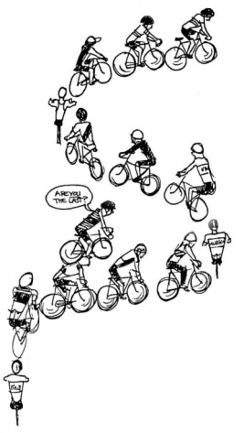

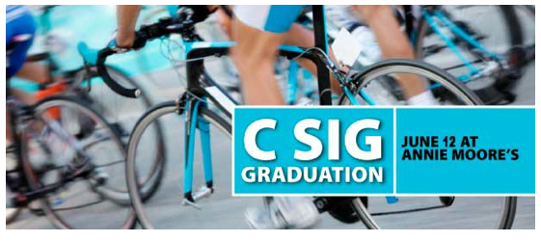

June 12th Club Meeting - C-SIGGIES Graduate!
To all 2012 C-SIGGIES: Our June 12th meeting is NYCC's official acknowledgement of your efforts and success − the C-SIG graduation!
Come and enjoy your well-deserved recognition.

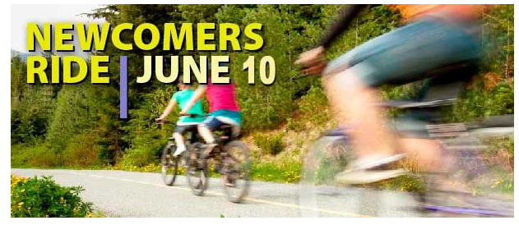
Welcome New NYCC Members!
Sunday, June 10th is NYCC's annual Newcomers Ride, round-trip from the Central Park boathouse parking lot to the Goswick Pavillion in Piermont, NY.
The mileage, depending on the group you choose to ride with, will vary from approximately 45-65 miles. All rides will go over the George Washington Bridge (south side bike path) in both directions, and will be led by experienced NYCC ride leaders.
Signup for the Newcomers Ride of your choice at Upcoming Rides. That's where you'll find your meet-up time.
Cue sheets will be provided to all participants at the start of the ride. Bring a cue sheet holder or small binder clips to attach the cue sheet to your cables.
Usually, NYCC rides stop at lunch and everyone buys their own, but this lunch is on us!
Delicious hero sandwiches (meat or vegetarian), drinks, and cookies to fuel your ride.
Welcome Newcomers! We hope you'll join us!
Guaranteed, you won't find a more festive way to ease into the Club!

Join NYCC this July 4th in Cold Spring!
Thanks to the gracious hospitality of NYCC lifetime members Christy Guzzetta and Jody Sayler, we'll enjoy a fabulous July 4th of cycling, swimming, food, and fireworks in Cold Spring, New York.

We'll grab the 7:50am train from Grand Central and meet up at Christy and Jody's lovely Cold Spring home, steps from the station. That's the departure point for A, B and C rides. Or by all means, drive up.

Check for specific rides under Upcoming Rides or submit your own!

If you would like to lead a July 4th ride, please let Christy know.

Later on there's swimming and food back at Christy and Jody's, and then an escorted tour of the historic village of Cold Spring, followed by evening fireworks on the Hudson.

Don't hesitate to bring a significant other, even if they don't cycle. Cold Spring's main street is lined with charming antique shops and cafes.

Two train options return us back to NYC: either the 3:05pm or the 10:00pm.

So, join us this July 4th for our 236th Independence Day and plenty of cycling, swimming, food, friends, and fun!

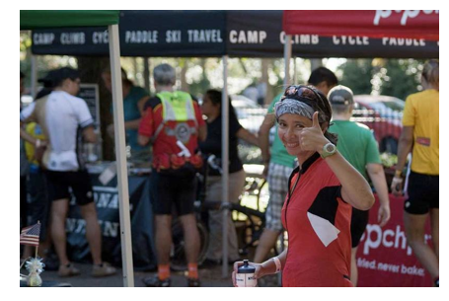
Escape New York, Saturday, September 22, 2012

Spread the word that registration is now open for Escape New York − the highlight of the fall riding calendar in the New York City area!

Mark your calendar to volunteer for ENY and help others enjoy the hospitality of the New York Cycle Club as we go all out to deliver a food- and fun-filled, fabulous day of riding to all our friends in the cycling community. Details on how to volunteer to come soon!

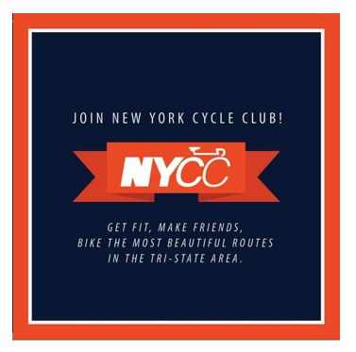
NYCC Postcard Distribution
Let's get our beautiful new Join New York Cycle Club! postcard, designed by NYCC member Cathline Marshall, in every bike shop and bike hangout in the five boroughs and beyond.
Pick up a pack at the June 12th Club meeting and make sure your own local shop is supplied!

Our Newcomers Ride − An Amazing Success!

A crowd of 250 showed up for Sunday's ride. Happy and hungry cyclists rode in for lunch at Goswick Pavilion in Piermont!

It took 17 four-foot heroes, a load of water, soda, cookies and chips to feed everyone.

Here's some of our stellar prep crew holding a hero: Harv Bedi, John Siemens, Angelica Ocasio and Jim Olson.

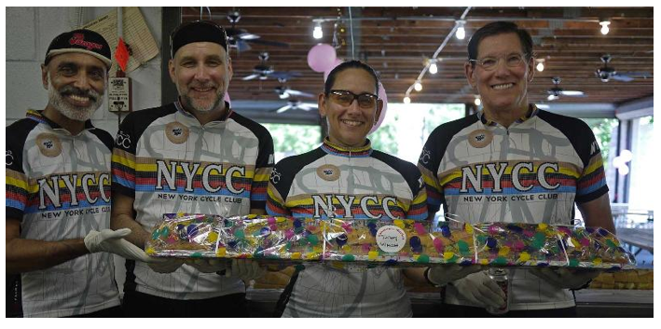

Post-ride Social Saturdays at Hudson Beach Café
Starting June 16, Hudson Beach Café is NYCC's post-ride watering hole!
Stop by after your ride and enjoy a frosty ale with fellow members.
Dates
Our Social Summer Saturdays begin on June 16 and happen every Saturday through September 8th.
Directions
P.D. O'Hurley's Hudson Beach Cafe is located at 105th Street inside Riverside Park. Enter at 103rd and Riverside Drive at walk down the pathway. P.D. O'Hurley's is opposite the Dog Run.
Time
2:00pm - 5:00pm
See you there!

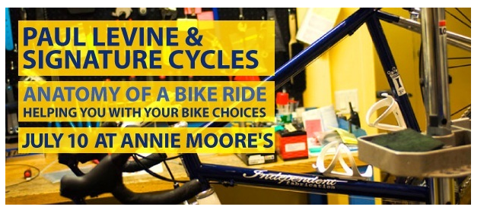

July 10th Club Meeting

Are you thinking about buying a new bike or upgrading your components?

Do know the pluses and minuses between carbon, titanium, steel and aluminum as frame materials?

Should you choose Shimano, Campagnolo or SRAM as components?

Come to the July 10th meeting to learn about this and more, as Paul Levine will help you decide what bike and components are right for you.

Signature Cycles has generously agreed to sponsor our July meeting, by donating valued cycling items for our raffle, highlighted by: a custom bike fit, (valued at $375.00), Shimano sunglasses and Signature Cycles jerseys.
NYCC Wool Jersey Fitting at July 10 Club Meeting

NYCC will soon be selling a beautiful wool jersey of fine merino wool by Soigneur of New Zealand to our members.

The sizing is unisex. The price is $160.

We will have samples to inspect and try on at our July 10 Club meeting at Annie Moore's starting at 6:00pm.

It is highly recommended you come and try on the jersey before purchase.

As these are custom manufactured and preordered, there will be no returns.

Come to the July 10 meeting and check them out!

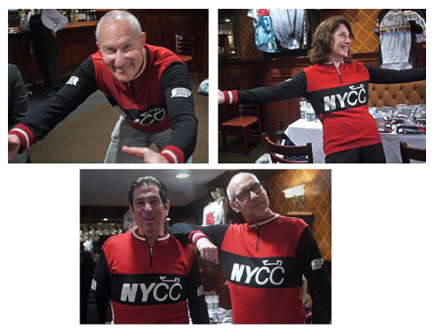
Counterclockwise: Eden Weiss, NYCC Programs Chair, Janet Zinberg, John Siemens, NYCC Incentives Coordinator, Artie Nathan − all sporting the new jersey at our June 12 try-on.

Members Corner
This is where NYCC shares cycling experiences as submitted by our members.

Did you just complete an awesome cycling trip? Is there some cycling knowledge you wish to share?

Email your write-up to bulletineditor@nycc.org.

This month's submission is by Jay Jacobson, an NYCC member since 1992, who writes about his trip to France.

Read "500 Exquisite Miles in Provence and Alsace, Including a Shivering Epic 13-Mile Climb of Mont Ventoux".

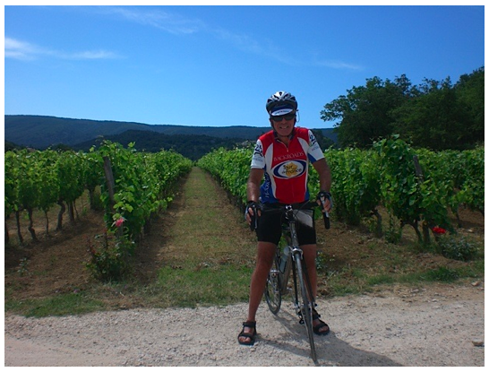

Central Park Alert

Be aware that a recent outbreak of roadway carpet tacks at the north end of Central Park has been wreaking havoc on tires.
Riders descending Harlem Hill have gone down because of the booby-trapped road surface, particularly near the intersection with the 103rd transverse.
The Conservancy and Central Park Police have been alerted.
Be aware of this danger!

Important Ride Submission Guideline
To maintain a fair standard of responsibility for achieving ride leader credit within the NYCC incentive program, the number of Ride Leaders for any particular ride should be appropriate for the number of participant spots allocated for that ride.
Ride Coordinators have the discretion to request that the number of co-leaders be reduced for rides with limited participant spots.

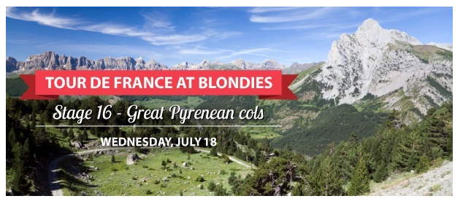
Tour De France Viewing At Blondies
Gather we will on July 18th to view one of the most exciting stages of this year's Tour − Stage 16 and the Great Pyreneans cols!
We've got the back room at Blondies and a $10 minimum per person.
Beer, good bar food, great viewing.
Time: 7:00pm
Date: Wednesday, July 18
Place: Blondies Sports Bar, 212 West 79th Street (between Amsterdam and Broadway)
As in past years and to simplfy paying the check − Blondies will compile one check for each table.
Therefore, we will need one mathematician at each table to compute the per person liability.

NYCC Ice Cream Social − August 7th
Let's celebrate summer with our annual NYCC Ice Cream Social on Tuesday, August 7th!
Come on down to the lovely Boat Pond and mix with fellow members on this August evening.
Ice cream - compliments of NYCC.
NYCC Membership is required for this event.
Knish Nosh Café also sells an assortment of foods in case you want to buy dinner before your dessert. If the weather is questionable, please watch the NYCC Message Board the morning of the social.
Date: Tuesday, August 7th
Time: 6:30pm - 9:00pm
Where: Knish Nosh Café at the Central Park Sailboat Pond, adjacent to the Model Boat House, 73rd Street and Fifth Avenue. Knish Nosh Café is located immediately down the hill upon entering the Park at 73rd and Fifth.
Sign up: Go to the Ice Cream Social page on our website and click the Sign up button at the bottom of the page.

Hudson Terrace Alert
The Fort Lee Police have asked that cyclists returning to Manhattan approach the George Washington Bridge as follows:
Continue south after the underpass where we normally would turn, getting into the left turn lane at the light at Bruce Reynolds Boulevard.
Make that left turn onto the sidewalk/bike path by the entrance to Fort Lee Historic Park and proceed to the Bridge pathway.
We are advocating that the turn directly after the underpass be reinstated as a viable and unticketed approach. Until that happens or until this matter is resolved in court, this is the recommended approach.
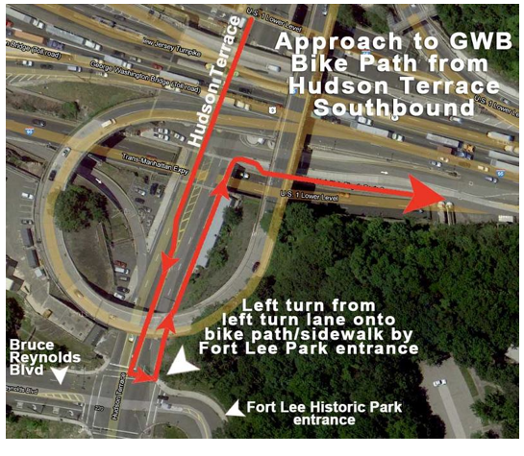

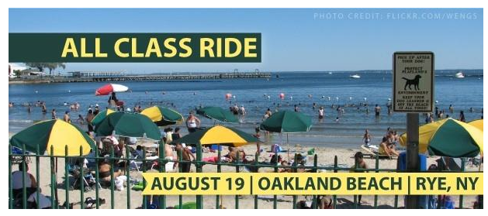
NYCC's Annual All-Class Ride Sunday, August 19th
Join us for what's sure to be a ride of the year − the 2012 All-Class Ride.
Destination: Oakland Beach in Rye, New York, overlooking Long Island Sound.
And a delicious lunch is on the Club!
Swimming is optional for a $10 park fee − so consider bringing your suit and a towel if the temps justify.
Groups will be available for every ride level.
Check our ride listings for the group that's right for you and please make sure you signup for that ride online!
NYCC members only.

Important Ride Sign-Up Etiquette
If you cannot attend a ride for which you are signed up, kindly remove yourself from the ride sign-up and free up that slot for others.
Ride slots are precious and many are wasting due to some who sign up and don't show up.
Thank you for not holding one you will not use.

NYCC Photos of the Week − July 29th Peddle and Paddle Ride
Ken and Marilyn Weissman led a fabulous bike ride to Sea Kayak Connecticut where NYCCers jumped from their bikes to colorful kayaks!
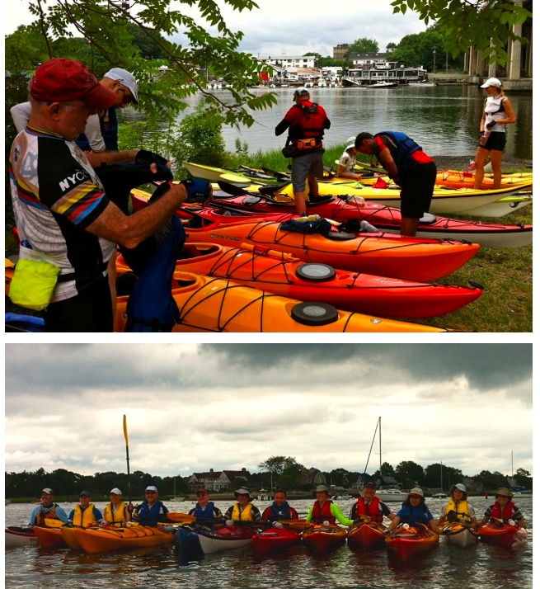

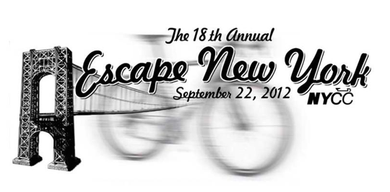
Escape New York needs volunteers for a variety of fun and rewarding jobs on Saturday, September 22nd.
The continuing success of ENY is largely due to the efforts of NYCC Club members and friends, so please come help us host NYCC's best event of the year.
VOLUNTEER NOW!

Members Corner
This is where NYCC shares cycling experiences as submitted by our members.
Did you just complete an awesome cycling trip? Is there some cycling knowledge you wish to share?
Email your write-up to bulletineditor@nycc.org.
This month's submission is by Kate Apostolova, an NYCC member, who writes about her first cycling tour.
Read "Cycling Tour of the Big Island, Hawaii!"
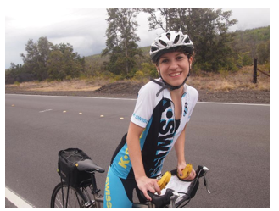

NYCC's All-Class Ride − A Total Success!
Over 200 NYCC members of all levels enjoyed the All-Class Ride to Oakland Beach! NYCC member Alicia Rau, who played her small trumpet, and accordionist Matt Dallow added to the festiveness at lunch. The pictures tell the tale...

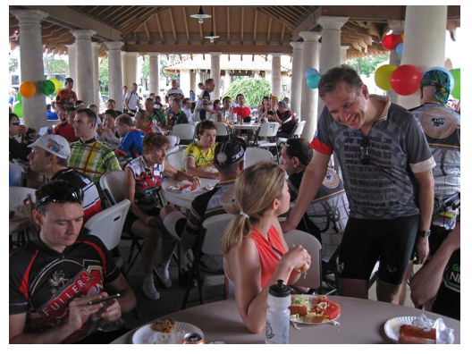

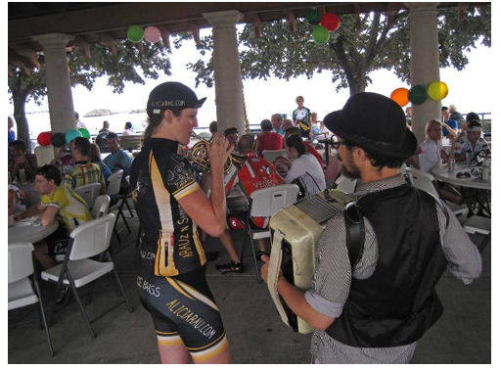

New Jersey Transit Bike Access Changes

Newly revised Bike Aboard program expands travel options for bicyclists effective August 11, 2012.

"After gathering valuable input from members of the cycling community, we worked to make some common-sense changes that help make NJ TRANSIT one of the most bicycle-friendly systems in the region," said NJ Transit Commissioner Simpson. "By implementing designated bike trains on weekends on most of our rail lines, in addition to the regular weekend trains, we are providing capacity for up to 7,200 bicycles on Saturdays and Sundays combined."

Effective Saturday, August 11, all weekend trains on the Raritan Valley Line and Atlantic City Rail Line and on rail service to and from Hoboken Terminal will become "bike-friendly" trains, providing capacity for up to 12 bicycles per train.

The current policy allows for bicycle access only on open rail cars, meaning if four cars of a six-car train are open to customers, that train can accommodate only eight bicycles. Under the newly revised Bike Aboard program, train crew members will be able to open unused rail cars on designated bike trains as needed to provide additional capacity for cyclists.

As part of the expanded Bike Aboard program, NJ TRANSIT will be offering 418 designated bike trains on weekends on the Raritan Valley, Main/Bergen County, Pascack Valley, Gladstone, Montclair-Boonton and Atlantic City Rail lines. An additional 273 non-designated bike trains on weekends can accommodate up to two bicycles per car on the Northeast Corridor, North Jersey Coast and Midtown Direct lines.

Starting in October, NJ TRANSIT rail timetables will be reprinted to clearly indicate designated bike trains with a special bicycle icon near the train number.

Thanks to NYCC member Neile Weissman for so effectively leading the charge on this initiative.

NYCC Board of Directors Nominations Open September 1st!

Nominations for the NYCC Board of Directors will open on Saturday, September 1st and will stay open until Tuesday, October 9th, the date of our October Club meeting.

Below is a list of the Board positions. For an explanation of the duties involved, review the
NYCC Bylaws >

Any member may run, with the exception of the office of president for which you need to have been a club member for one year.
President
Vice President of Programs
Vice President of Rides
Secretary
Treasurer
Public Relations Director
Editor
Webmaster
Membership Director
Special Events Coordinator
A Rides Coordinator
B Rides Coordinator
C Rides Coordinator
Escape New York Director
Incentives Coordinator

Members can send nominations to: president@nycc.org
Please copy: MoreneKB@gmail.com

NYCC is a member of:

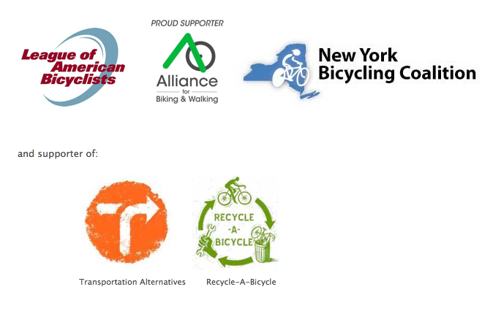

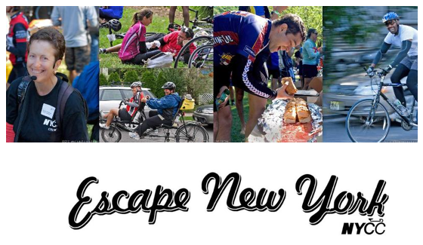
Saturday, September 22, 2012
Escape New York needs volunteers for a variety of fun and rewarding jobs on Saturday, September 22nd.

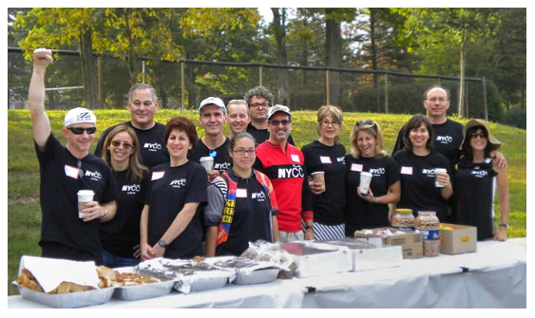
The continuing success of ENY is due to the efforts of NYCC Club members and friends, so please come help us host NYCC's best event of the year.
VOLUNTEER NOW!
Questions? Contact our Volunteer Coordinator at ENYvolunteers@nycc.org

